Following changes are suggested for TAERI App.
- Welcome Page contain the following thins:
TAERI
Tag Line: Predicting Risk. Preventing Fall. Protecting Independence.
What is TAERI?
TAERI (Task Assessment for Ease, Risk & Independence) is an innovative digital health platform that identifies fall risks and functional decline before serious incidents occur. By assessing everyday activities and environmental factors, it supports early intervention, promotes independent living, and helps improve the quality of life of older adults.
- In the app before starting the assessment we need to define week like week # 1, Week # 2, something like that…
- Need to store the previous week records to compare (we need it for portal)
- Need to improve control button it must be little bit up for ease of use
- Write heading Frequency & Duration of a Task
- In adopted postures change the picture of Unsupported posture
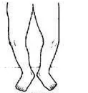  One or both legs are bent from knees  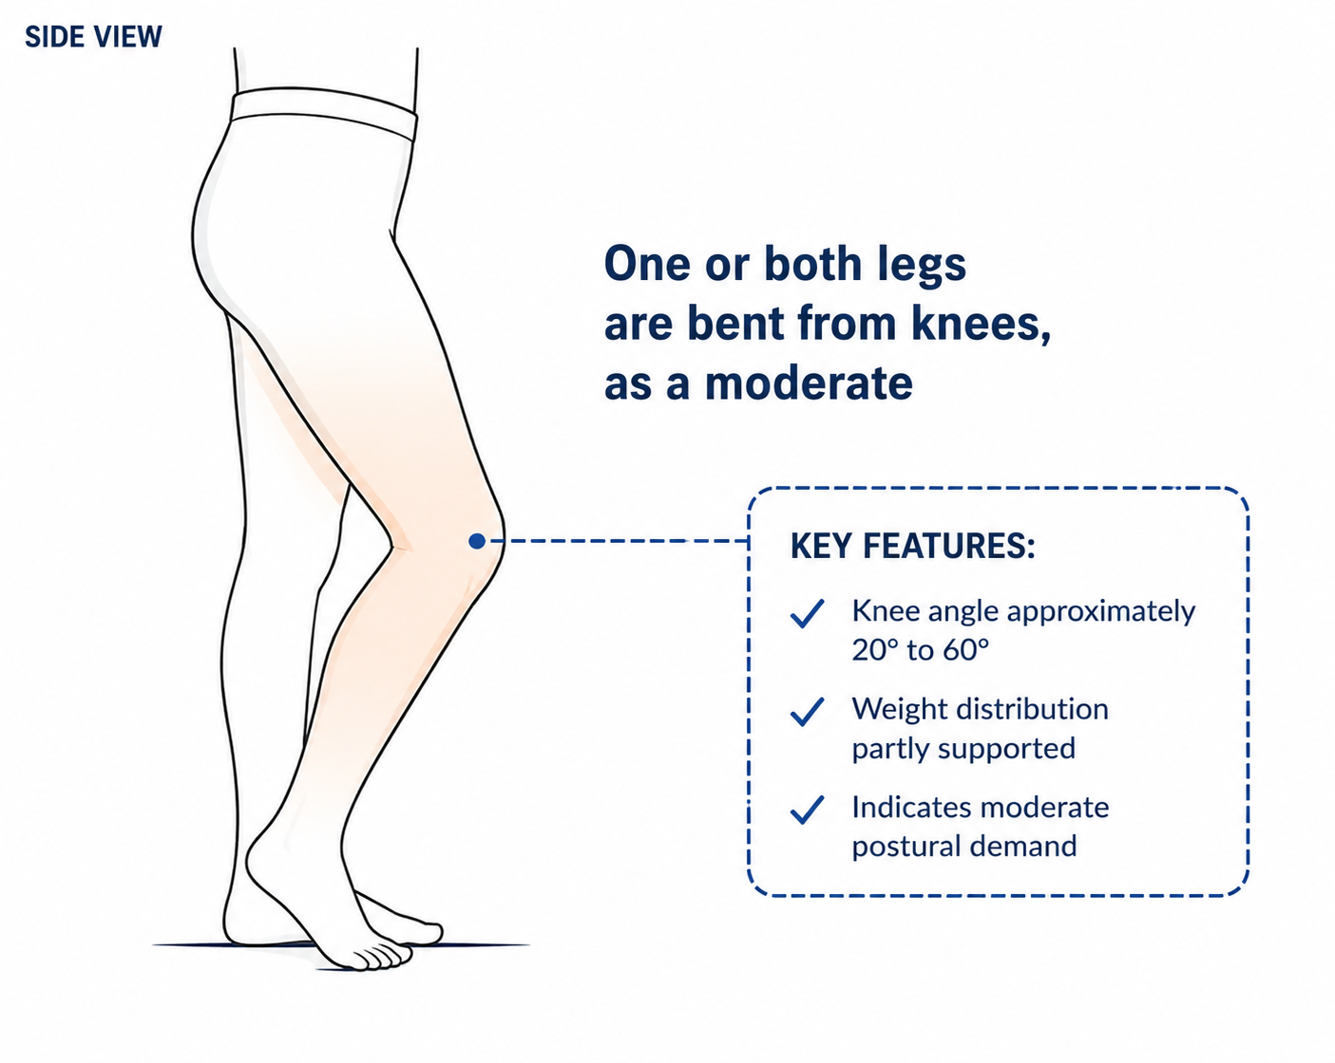 | 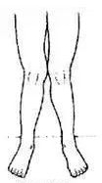  Legs are un supported and bent from knees (flexion) more than 30°  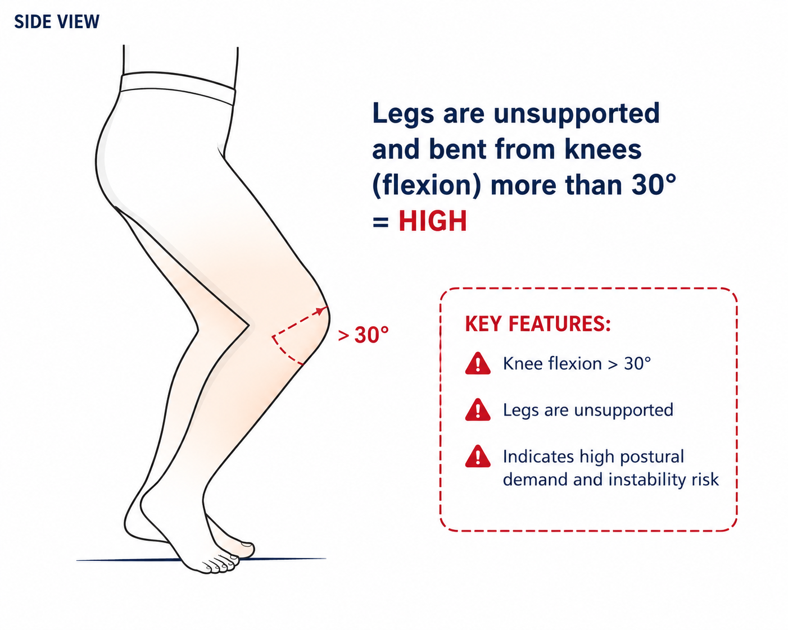
Moderate | High

- Heading Manual Handling
- Heading Stability During Task Performance also add Question: How stable did you feel while performing the task?
- Add Fall Risk like : Very Stable = Low (in backend) , Somewhat Unsteady (in backend) = Moderate, & Very Unsteady= high (in backend)
- On the result screen
- Assessment complete
- Low Risk
- Instead of IADL Exposure Score write Task Exposure Score
- Show Fall Risk (Low, moderate or high) instead of TSL Level

- In my Analytics show graph of fall risk also, also show average task exposure score for whole week (average of all tasks risks) and fall risk of whole week (use mode of all risks in the current week).

